New Executive Board Member

ENISA, the European Union Agency for Cybersecurity hosted the meeting of the ENISA Management Board on 20 and 21 November in Athens.

Published on November 21, 2019

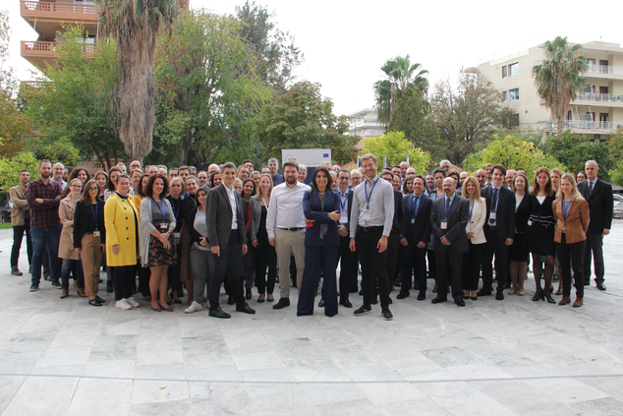

Tagged with

* [Executive Board](https://www.enisa.europa.eu/search?Subject%3Alist=Executive%20Board)
* [Executive Director](https://www.enisa.europa.eu/search?Subject%3Alist=Executive%20Director)
* [Management Board](https://www.enisa.europa.eu/search?Subject%3Alist=Management%20Board)
* [Juhan Lepassaar](https://www.enisa.europa.eu/search?Subject%3Alist=Juhan%20Lepassaar)

Today, ENISA held a management Board meeting, chaired by Jean Baptiste Demaison of ANSSI. This included a workshop with the members of the Management Board (MB) and ENISA staff on the preparations for the Agency’s future strategy.

Elections for a member of the ENISA Executive Board (EB) was also held during the two days meeting. The role of the Executive Board is to prepare decisions to be adopted by the Management Board.

We warmly congratulate MB Member Mr **Hans de Vries** from The Netherlands and Member Mr **Rastislav Janota** from Slovakia on their election to the EB as member and alternate, respectively.

The MB’s role is to ensure that the Agency carries out its tasks under conditions, which enables it to serve in accordance with the founding Regulation. The MB is composed of one representative from each EU Member State and two representatives from the European Commission are also part of the Board.

The Agency amicably thanks Ms. **Despina Spanou** for her engagement, commitment to the ENISA EB and for helping to advance cybersecurity in Europe. We wish her all the best in her future endeavours.